Round Trip Time (RTT)

1. Aka Round Trip Delay time (RTD)
2. It is the length of time it takes for a signal to be sent plus the length of time it takes for an acknowledgement of that signal to be received.
3. This time therefore consists of the propagation times between the two endpoints of the signal.
4. If T is the propagation time, RTT: 2 \* T
5. 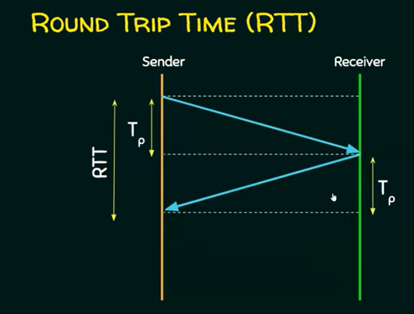
6. RTT ~= 2\*Tp